A Complete Report on Regulatory Intermediaries in Five EU Green-Transition Acts
  - Theory, CELEX corpus, R-I-T reconstruction, AI-assisted protocol and human audit
Igor Caires Machado
2026-09-06
Table of contents

Executive summary
This report documents the fourth, five-act round of PoC 01 on regulatory intermediaries. It is prepared for Prof. David Levi-Faur and is designed to make the whole path auditable: conceptual reading, CELEX selection, legal-text collection, lexical screening, R-I-T reconstruction, AI-assisted coding and human adjudication.
The governing instruction is: Do not code labels; code regulatory relationships. A word such as “auditor”, “benchmark” or “competent body” is only a screening signal. The unit of interpretation is a supported relationship between a rule-maker/regulator, an analytically distinct intermediary and a rule-taker/target.
The corpus contains five known EUR-Lex acts: the Corporate Sustainability Reporting Directive (CSRD), the EU Ecolabel Regulation, the Climate Benchmarks Regulation, the ETS Verification Regulation and the Taxonomy Regulation. The five preserved HTML files are non-empty, hash-linked to the manifest and screened with one versioned pipeline. The four historical acts reproduce the v3 total of 1,079 screening hits; the Taxonomy Regulation adds 13, for 1,092 hits in all.
The current authoritative R-I-T table deliberately preserves the seven human-validated v3 relationships. Twenty new units, four per act, were sampled with a reproducible seed and remain pending independent human adjudication. No Taxonomy R-I-T relationship is asserted from a lexical hit alone.
The live OpenAI integration was implemented and tested against the account’s model list, with gpt-5.6-terra fixed as the operational model id. The first generation request returned credit_balance_exhausted; therefore, this delivery contains no substantive LLM finding. A 201-call local dry-run (A2/B1/B2 for 20 units and C for seven inherited relationships, each repeated three times) passed schema and orchestration checks, but its placeholders are not results and are not used in the datasets or conclusions.
The prompt-based estimate for those 201 live calls is approximately US$2.2027 at the published gpt-5.6-terra rates. This is a planning proxy, not an invoice; the account dashboard is authoritative.

Research context and task
The task is a methodological proof of concept for a larger study of regulatory intermediation. It asks how legal and institutional arrangements place actors between regulators and targets, which mechanisms they use, and which design features may support autonomy and accountability. The present delivery is addressed to David as a transparent hand-off: it records what the legal corpus can support, what the workflow has tested, and what still needs human or external evidence.
The core analytical distinction is relational. Actor roles are not intrinsic properties: Role(actor) != intrinsic property; the relevant coding unit is Role(actor, relationship). The same organisation may be R, I or T in different relationships. For this reason, the dataset distinguishes rule_source, standard_setter, direct_regulator, oversight_authority, enforcement_authority, intermediary and target; R_actor_id is the focal role in one reconstructed relationship, not a permanent actor type.

1. Conceptual starting point

1.1 The construct proposed by Levi-Faur
The theoretical construct is regulatory intermediation: an analytically distinct actor operates between a rule-maker or regulator and a rule-taker or target. The central move is from a dyadic regulator-target picture to a relationship in which someone certifies, audits, ranks, rates, labels or reports on behalf of a regulatory arrangement.
The proposal organises this field around a triad of actors, mechanisms and strategies. It also asks how intermediary design connects to autonomy, accountability, governance modes and, in future work, democratic outcomes.

1.2 This PoC’s operational proposal
This exercise separates three analytical levels:
- Theoretical construct: regulatory intermediation.
- Operationalisation used here: a five-condition R-I-T test, four mechanism families and individual institutional attributes.
- Future analytical possibilities: diffusion, regime-level structure, effectiveness, legitimacy, trust and index construction.
The third level is not silently coded in this report. In particular, the dataset contains no autonomy index, accountability index, effectiveness, legitimacy, trust or polycentricity score.

1.3 Mechanisms and strategies
The four mechanism families are the proposal’s own empirical scaffold:
Mechanism | Typical governance mode in the proposal | Operational signal in this PoC
Reporting | State-led | disclosure, report, sustainability reporting
Certification | NGO-led / scheme-led | certification, competent body, accreditation
Ranking/rating | Business-led | benchmark administrator, rating, ranking, score
Auditing | Profession-led | auditor, assurance, verification, audit firm
The mechanisms are not mutually exclusive. The ETS case, for example, can place auditing and accreditation in a chain. responsibilization and empowerment remain independent strategy batteries rather than a forced either/or variable; they are not scored here.

1.4 Why the EU green transition?
The five acts span reporting, environmental labelling, climate benchmarks, emissions verification and sustainable-finance classification. Together they offer variation in public authority, professional assurance, private scheme administration and technical classification. This is a purposeful methodological sample, not a claim to represent all EU green-transition law. The Taxonomy Regulation is included as an exploratory discriminant case: its signals may illuminate where classification and disclosure do not amount to intermediation.
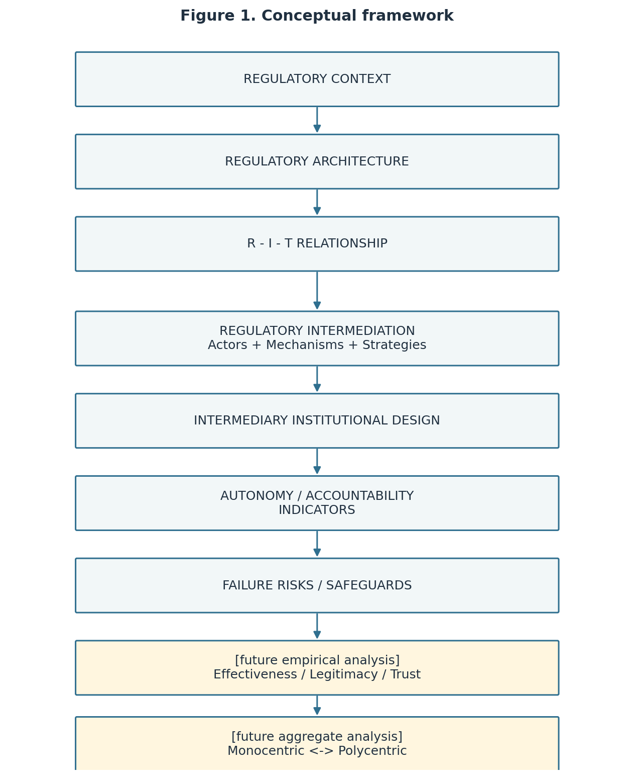
Figure 1. Conceptual framework from regulatory context to future empirical and aggregate analysis.

2. Corpus and CELEX rationale

2.1 Why CELEX/EUR-Lex
CELEX identifiers make the corpus selection explicit and reproducible. The pipeline requests a known English HTML record by identifier rather than using an unconstrained keyword search. Each response is preserved as received, normalised only for screening text extraction, and linked by SHA-256 hash.
Act | CELEX | Role in the design | Collected file
Directive (EU) 2022/2464 — CSRD | 32022L2464 | reporting and assurance | csrd_raw.html
Regulation (EC) No 66/2010 — EU Ecolabel | 32010R0066 | certification | ecolabel_raw.html
Regulation (EU) 2019/2089 — Climate Benchmarks | 32019R2089 | ranking/rating, conditional validity | climate_benchmarks_raw.html
Implementing Regulation (EU) 2018/2067 — ETS Verification | 32018R2067 | auditing and accreditation | ets_verification_raw.html
Regulation (EU) 2020/852 — Taxonomy | 32020R0852 | exploratory sustainability/finance case | taxonomy_raw.html
The source links are the EUR-Lex records for CSRD, EU Ecolabel, Climate Benchmarks, ETS Verification and Taxonomy.

2.2 Manifest and preservation
data/CELEX_MANIFEST_v4.csv records the base and version CELEX, ELI, title, act type, legal-status/version placeholders, URL, collection timestamp, response version description, byte count, relative path and hash. The JSON mirror supports machine reading. A base act and a consolidated or versioned record are not counted as separate acts. scripts/validate_v4.py checks that all five files exist, are non-empty and reproduce their manifest hash.

From the PoC corpus to the target population
This PoC corpus is not the target population. A population-scale study first needs a substantive definition of “EU green-transition act” (for example, legal instrument types, policy domains, dates, and inclusion/exclusion of amending and consolidated texts), followed by a frozen retrieval query and a version-handling rule. SPARQL/Cellar solves retrieval, not population definition. The manifest therefore makes the five-act choice inspectable without pretending that the five acts are a prevalence denominator.

Operational framework and pipeline
The implemented sequence is:
EUR-Lex -> A1 + A2 -> candidate pool -> B1 -> B2 -> human adjudication -> C -> D validation/error analysis -> authoritative data.
A1 writes one row per provision and lexical signal. A2 is a complementary semantic pass. B1 reconstructs all actors and relations before assigning roles; B2 applies the five-condition test. Human review is a gate, C codes institutional attributes only for positive relationships, and D checks foreign keys, missingness, evidence and errors. The live AI layer can propose records but cannot write directly to the authoritative CSVs.
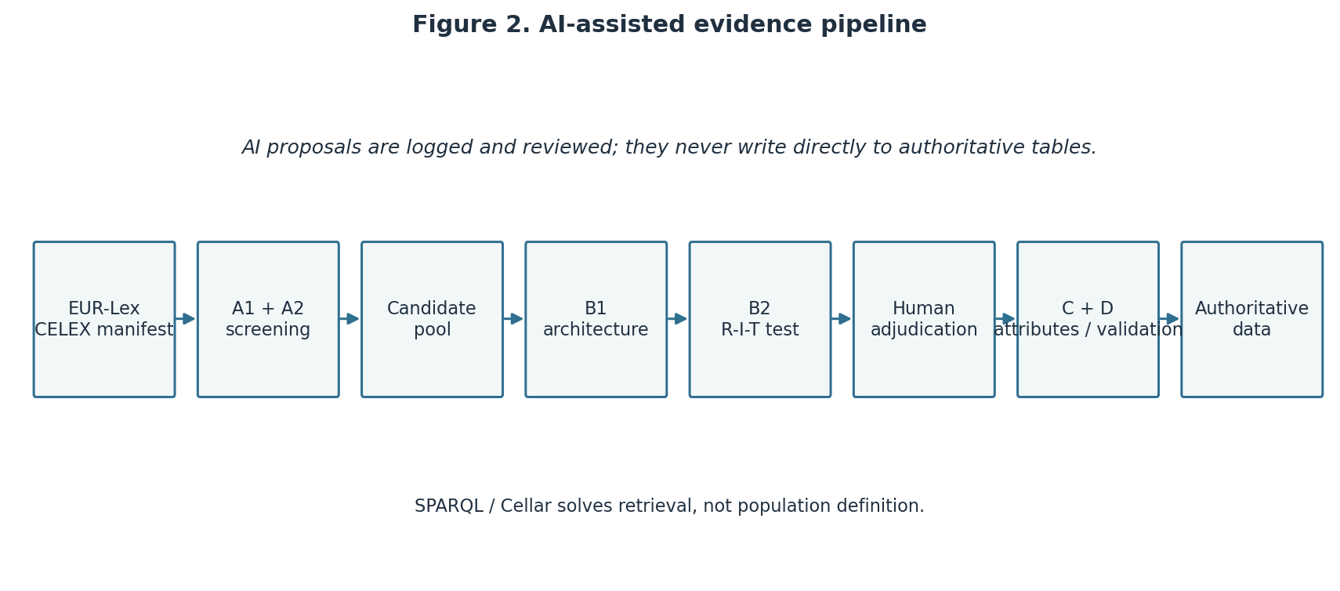
Figure 2. AI-assisted evidence pipeline with human and validation gates.

3. Extraction and screening

3.1 Stage A1 lexical screening
The screening script tracks the carrier article while traversing paragraph nodes. It applies independent rules for actor, mechanism and instrument. This prevents a phrase such as “verification report” from being treated as if the report and the verifier were the same ontological object.
Anchor patterns receive high confidence; generic terms receive low confidence. The evidence_text field keeps the exact normalised paragraph used for the hit. This is salience screening, not a decision that a third actor actually mediates a relationship.

3.2 Screening result
Act | CELEX | Hits | High | Low
CSRD | 32022L2464 | 559 | 472 | 87
EU Ecolabel | 32010R0066 | 94 | 73 | 21
Climate Benchmarks | 32019R2089 | 61 | 37 | 24
ETS Verification | 32018R2067 | 365 | 182 | 183
Taxonomy | 32020R0852 | 13 | 5 | 8
Total | five CELEX | 1,092 | 769 | 323
The four-act subtotal is exactly 1,079, matching the v3 baseline. The Taxonomy result is small but non-empty. Its 13 hits trigger closer inspection; they do not by themselves show that the Taxonomy Regulation creates an intermediary.
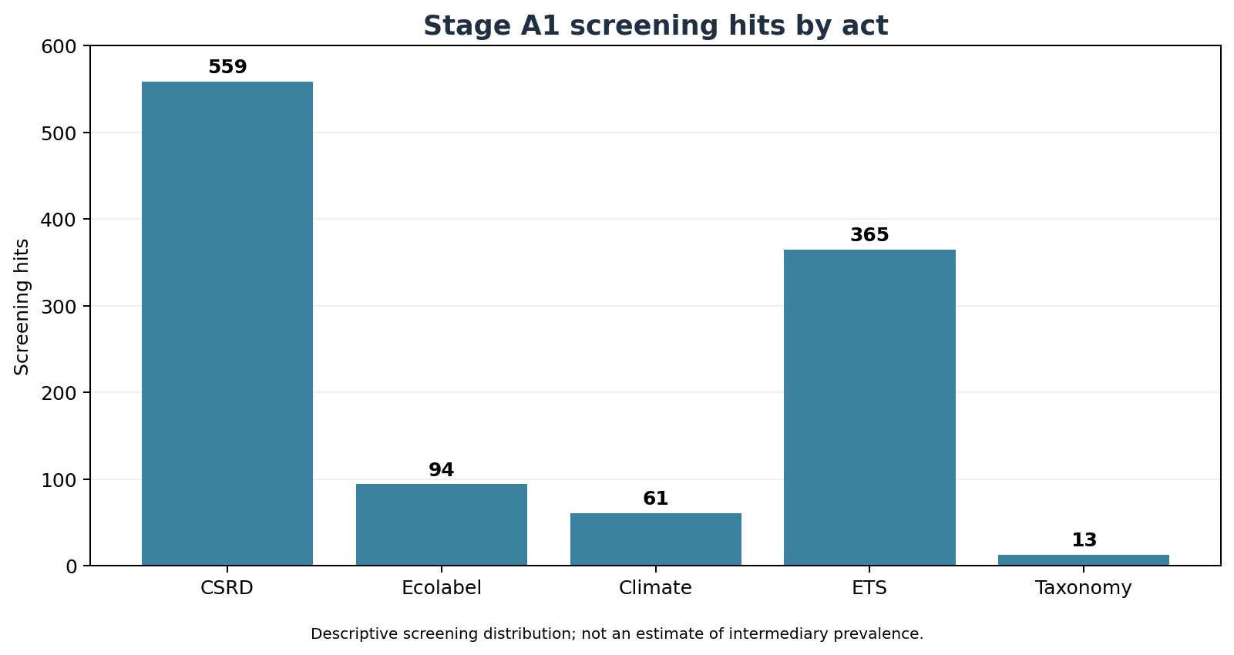
Distribution of Stage A1 screening hits. The figure is descriptive and does not represent an estimate of intermediary prevalence.

3.3 Candidate discovery channels
Candidate discovery is kept decomposable: LEXICAL, SEMANTIC_AI, BOTH and HUMAN. In this delivery the 20 held-out units are lexical-screen selections and the A2 records are dry-run placeholders. Therefore the lexical/AI intersection, lexical-only population and AI-only discoveries are not substantively measured. The zeros in the status table mean “not measured”, not “no such cases exist”.
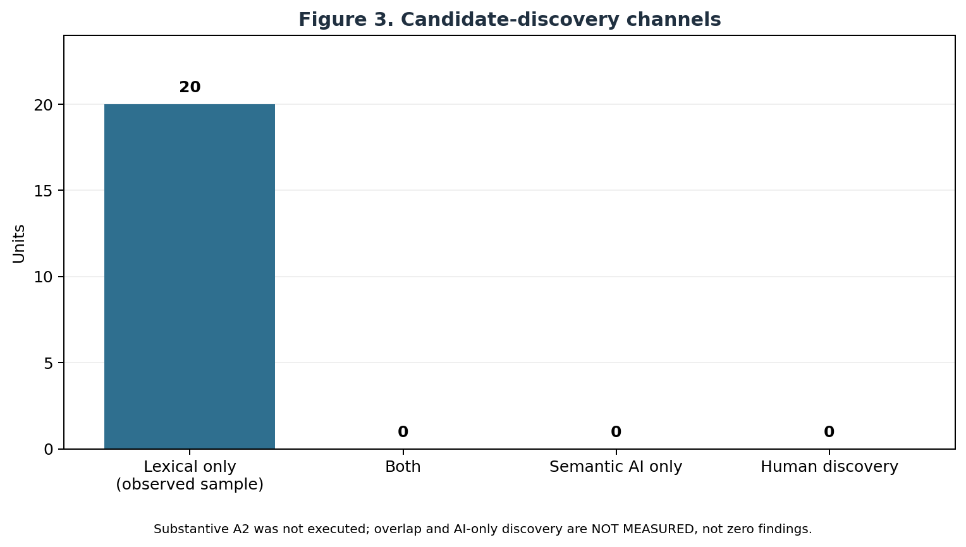
Figure 3. Candidate-discovery channels. AI-only and overlap values are explicitly not measured.
Discovery category | Current v4 status | Interpretation
LEXICAL_ONLY | 20 observed sample selections | selected from A1; A2 was not substantive
BOTH | Not measured | requires substantive A2 on the same units
SEMANTIC_AI_ONLY | Not measured | dry-run placeholders cannot establish discovery
HUMAN | Not measured | no new human discovery adjudication completed

4. From R-T to R-I-T

4.1 The five-condition test
Each candidate is evaluated in order:
- Is an identifiable regulator or rule-maker present?
- Is an identifiable target or rule-taker present?
- Is a third actor analytically distinct from both?
- Does the third actor perform a regulatory function mediating the R-T relationship, rather than merely advising the regulator or sharing the target’s obligation?
- Is the relationship supported by explicit legal text or a documented institutional reconstruction?
Only five YES answers produce positive. A NO produces negative. An UNCLEAR condition produces conditional or insufficient_evidence. A direct reporting obligation may therefore be a negative R-I-T case, as in the v3 negative control CAND-03.

4.2 Architecture before classification
Stage B1 reconstructs all named actors and explicit relations before any R/I/T assignment. This guards against prematurely treating an accreditation body as the regulator and missing a peer-evaluation actor above it. Stage B2 then receives the architecture and answers the five conditions separately.
The ontology remains decomposed:
Ontology | Question
Actor | Who is named or directly implied?
Mechanism | What regulatory activity mediates?
Instrument | What report, methodology, certificate or rating artefact is used?
Procedure | What sequence of application, review, verification or appeal is specified?
Institution | What authority, body, profession or organisation occupies the role?

4.3 Current relationship baseline
The current v4 relationship file preserves seven human-validated v3 rows. It contains the two-level CSRD assurance chain, the Ecolabel certification and testing relations, and the ETS verification/accreditation chain. Every row has R, I and T foreign keys, pairwise distinct actors and literal legal evidence.
Relationship family | Relationships | Reading
CSRD | RIT-001, RIT-002 | auditing, with reporting in the upstream chain
EU Ecolabel | RIT-003, RIT-004, RIT-005 | certification and testing/accreditation
ETS Verification | RIT-006, RIT-007 | verification plus accreditation/meta-regulation
Taxonomy | none asserted | exploratory; new units pending adjudication
Negative and conditional cases remain in the candidate layer and are not entered into the positive relationship table.
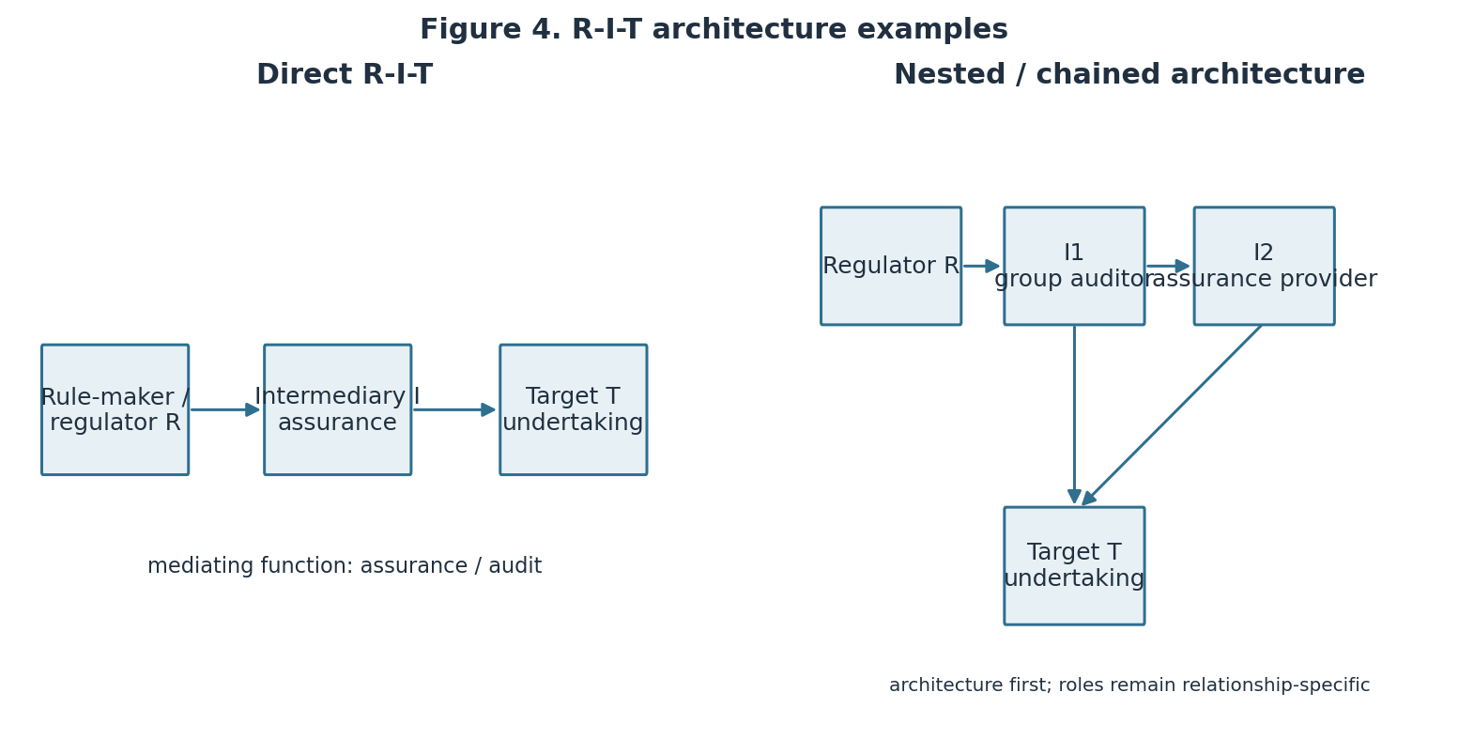
Figure 4. Direct and nested R-I-T architecture examples.

5. Institutional attributes
For positive relationships, Stage C is restricted to individual attributes: formal role, voluntariness, mandatory use, regulatory level, sphere, mode of operation, centrality, organisational separation and legal independence. The eight attribute families are formal role, voluntarism, level, sphere, motivation, mode, centrality and separation; supervision is retained as a separate accountability-related field. Each value carries evidence, observability class and confidence. autonomy and accountability batteries remain deferred proposals. A conflict of-interest rule would indicate a design response to capture; it would not show that capture occurred.
The same discipline applies to accountability: a named supervisory function can support supervision_present = 1, but that is not an accountability index and says nothing by itself about effectiveness or legitimacy.

6. AI-assisted coding protocol

6.1 Scope and safeguards
The AI layer is an assisted proposal layer. It does not replace the R-I-T test, and it cannot write directly into the authoritative CSVs. The four stages are:
- A2: semantic candidate detection complementary to A1;
- B1: architecture reconstruction;
- B2: five-condition R-I-T adjudication;
- C: institutional attributes for positive relationships.
The prompts require evidence before code, reward abstention, constrain the model to the supplied legal package, allow one bounded context request and prohibit outcome/index claims. Strict JSON schemas are validated after every call. Each unit is repeated three times, and substantive disagreement routes to human review rather than being averaged.

6.2 What was executed
The OpenAI adapter was wired to the Responses API with strict JSON Schema output and store=false. The exact model id selected for this implementation was gpt-5.6-terra, because the account model list exposed it and the current official model documentation lists Structured Outputs support for the family. The first generation call returned the provider error credit_balance_exhausted. No substantive response was accepted or logged.
To validate the rest of the pipeline without fabricating a finding, the local dry-run adapter was executed on 20 audit units: A2, B1 and B2 three times each, plus Stage C for the seven inherited positive relationships three times each. This yielded 201 schema-valid log records. All repeated placeholders were stable, but stability in a dry-run is only an orchestration result.
Model-selection component | v4 status
Primary model implementation | gpt-5.6-terra adapter implemented
Challenger model | Not executed
Tier 0 anchor comparison | Not scored: no substantive output
Tier 1 held-out comparison | Deferred: human adjudication and credits pending
Model winner / best-model claim | Not reported

6.3 Promotion path
All current AI-related rows are isolated in data/ai_runs_v4.jsonl, data/ai_runs_v4.csv and data/human_review_v4.csv. A future human promotion must inspect each literal quote, re-apply the five-condition test and record ai_assisted=1 plus an exact ai_run_ref. No such promotion has occurred in this delivery.

7. Human audit and held-out sample
The audit sample contains 20 new units, four per act, selected with seed 20260906. Articles used by the v3 candidate set were excluded. The sample is visible in data/audit_sample_v4.csv; all rows are PENDING.
The required sequence is deliberately strict: human adjudication must be completed before a live Tier 1 run, so that the model cannot anchor the human coder. The human record must identify R, I and T, answer conditions (a)-(e), quote evidence, flag conditional/negative cases and document cross-reference gaps. One adversarial case must omit a load-bearing cross-reference and check whether the model requests it instead of relying on parametric knowledge.
Because both the independent adjudication and the API credit gate are unfinished, this delivery does not report a Tier 1 score, model-selection winner or AI agreement rate.

8. Findings by act

CSRD
The inherited coding identifies a two-level assurance chain around sustainability reporting: a group auditor carries responsibility for the assurance report, and the group auditor evaluates the work of eligible subsidiary-level assurance providers. The separate direct reporting provision is retained as a negative control where the reporting duty itself has no third-party mediator.

EU Ecolabel
The inherited coding identifies competent bodies as certification intermediaries and separates testing/verification bodies from the competent body. Voluntary participation in the scheme and mandatory use of the competent body once an operator applies are kept as distinct variables.

Climate Benchmarks
The inherited candidate CAND-07 remains conditional. A benchmark administrator may be a relevant intermediary, but the specific R-I-T architecture must be supported by the relevant provision and not inferred from the existence of a benchmark label. Four new units are pending independent adjudication.

ETS Verification
The inherited coding distinguishes verification from the accreditation layer. The chain is methodologically important: a verifier mediates emissions reporting/verification for an operator, while accreditation and peer evaluation govern the verifier at another level. This is why the architecture must be reconstructed before roles are assigned.

Taxonomy Regulation
The Taxonomy Regulation is deliberately exploratory. Its classification system, disclosures and technical criteria produce lexical signals, but the current delivery does not presume that a platform, technical screening criterion, authority or reporting obligation is an intermediary. Four sampled units are pending the same five-condition test as the other acts.

9. Limitations and next steps
The lexical screen is not a prevalence estimate and cannot distinguish every institutional role. EUR-Lex HTML presentation can change, so the manifest and hash are essential. Full legal meaning may depend on cross-referenced acts; the context-request loop is bounded and unresolved gaps go to human review.
The present AI evidence is procedural, not substantive, because the provider account had no remaining credits. Before claiming a validated AI-assisted coder, the next round must:
- complete independent human adjudication of the 20 held-out units;
- restore account credits and repeat live three-run A2/B1/B2 calls;
- execute the adversarial omitted-context test;
- score evidence fidelity and mechanism validity by human review;
- update the model-selection results only after Tier 1, never from Tier 0;
- decide separately whether any further Stage C battery deserves scale.
Limitation | Control in this delivery | Remaining gap
Lexical salience is not intermediation | A1 is separate from B1/B2 | substantive adjudication
Cross-referenced law may be missing | bounded context escape hatch | retrieve and review requested sources
AI proposal may anchor a coder | human gate precedes Tier 1 | complete the 20 independent reviews
One provider could not generate | dry-run marked non-substantive | restore credits and repeat
Legal text does not show outcomes | no outcome/index fields | future external empirical study

10. Nested intermediation and governance of intermediaries
Nested coding uses nested_intermediation_present, chain_id, intermediation_level and parent_relationship_id. A meta_regulatory_relation is recorded only where the documented parent chain and evidence support governance of an intermediary by another arrangement. The ETS accreditation/verifier chain is retained as the stress case; it is not generalised to every multi-actor provision.
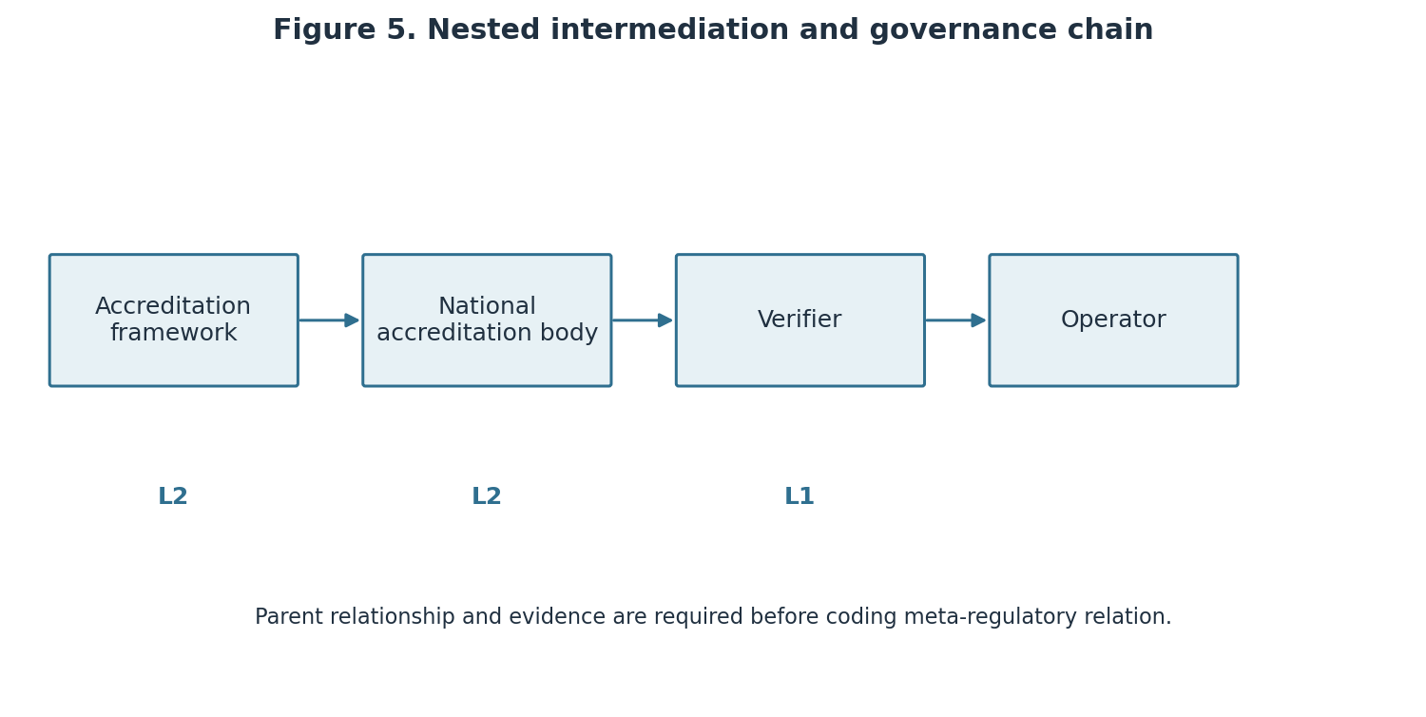
Figure 5. Nested intermediation and the governance chain.

11. AI performance, provenance and error analysis
The current run establishes schema validity, repeat-run orchestration and provenance fields, not AI accuracy. There is no substantive A2/B1/B2 output, no human-agreement rate, no evidence-fidelity score and no Tier 0/Tier 1 model winner. ai_runs_v4.csv and ai_runs_v4.jsonl retain provider, model, snapshot, reasoning setting, prompt/schema versions, timestamp, hashes, run_id, usage and cost estimate. human_review_v4.csv marks every proposal as pending.
The error analysis plan compares AI and Human 1 field by field, including evidence fidelity, condition-level errors, mechanism assignment, abstention and context requests. A second coder would be required before making any intercoder reliability claim.
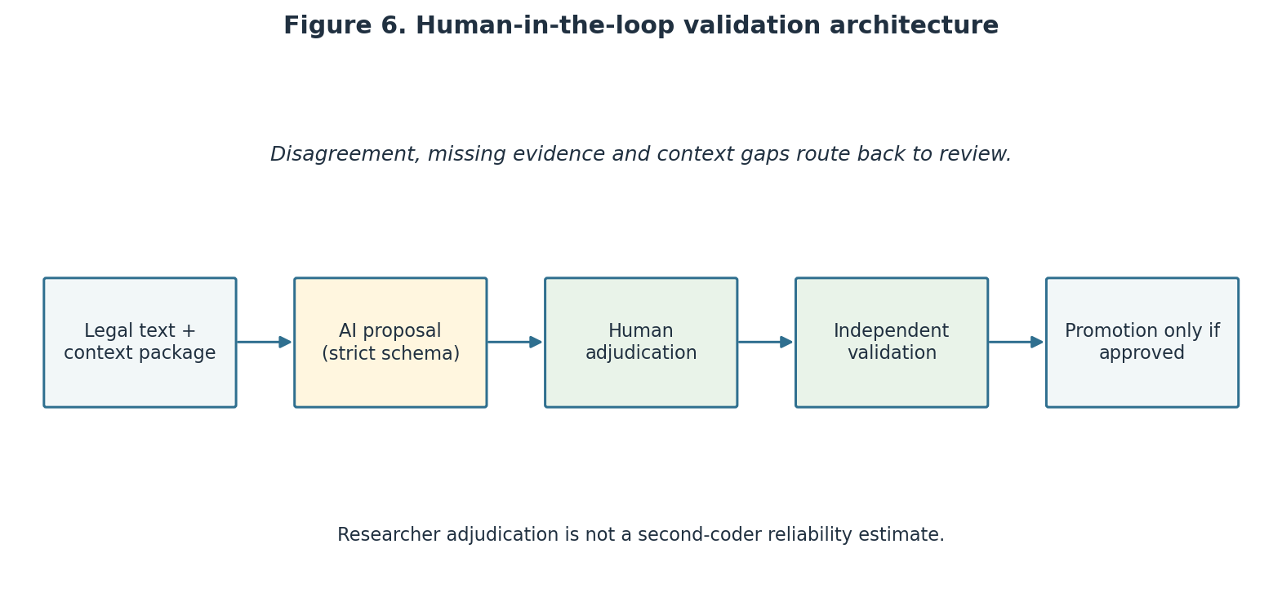
Figure 6. Human-in-the-loop validation architecture.

12. Construct validity and hard cases
The direct reporting case CAND-03 remains a negative control: a reporting duty does not itself create an intermediary. Climate Benchmarks CAND-07 remains conditional pending the relevant legal architecture. The Taxonomy case is exploratory and discriminant, with no presumption that criteria, classification or disclosure are intermediary mechanisms. The false- intermediary counterfactual is an interpretive aid, not a substitute for legal evidence.

13. What legal-text coding can and cannot measure
Legal text can support named actors, formal duties, procedures, explicit mechanisms, supervision requirements and bounded institutional reconstructions. It cannot by itself establish actual autonomy, capture, effectiveness, legitimacy, trust, compliance outcomes or democratic quality. It cannot turn an absence of wording into proof of absence. Missingness is therefore coded as NA, UNK, NOE or EXT as appropriate, and substantive categories are never silently left blank.
The independent strategy variables responsibilization_present and empowerment_present use 1, 0, UNCLEAR or NOE. They are not combined into a score. Failure fields describe design risks addressed by an arrangement; they do not show that capture or failure occurred.

14. Status of measured, deferred and planned elements
Element | State in this delivery | Interpretation
CELEX retrieval, hashes and A1 screen | Implemented and tested | five-act PoC evidence
Seven inherited positive R-I-T rows | Preserved and validated in v3 | regression baseline, not new AI findings
Twenty held-out human adjudications | Pending | no Tier 1 claim
Live AI generation | Blocked by account credits | no substantive model output
A2 lexical/semantic overlap | Not measured | requires substantive A2
Autonomy/accountability indicators | Deferred proposal | no indices
Effectiveness, legitimacy, trust, polycentricity | Future research | not observable from this PoC

15. From PoC to population-scale research
The next round should freeze the population definition, retrieve base and consolidated records with explicit deduplication, adjudicate the held-out sample, restore API credits, run a primary/challenger comparison where feasible, and publish the error taxonomy. CBAM is the proposed next stress test because it can probe another carbon-regulatory architecture; it is not part of this corpus and is not used to enlarge the present findings.

16. Conclusion
The delivery demonstrates the intended chain from theory to operationalisation, legal evidence, interpretation, structured data, validation and a scalable execution plan. Its substantive conclusion is deliberately narrow: seven human-validated inherited relationships are preserved; the five-act lexical screen is complete; new relationships, AI performance and population claims remain open until the specified human and account gates are completed.

References and primary sources
- The Levi-Faur proposal supplied for PoC 01 is the theoretical starting point and source of the mechanism vocabulary used here.
- EUR-Lex legal records provide the five CELEX sources listed in the corpus table.
- OpenAI model comparison and Responses API reference document the API features used by the adapter.

Appendix A — Reproduction commands
From the Entrega-04 directory:
python scripts/collect_v4.py
python scripts/screening_v4.py
python scripts/prepare_samples_v4.py
python scripts/build_datasets_v4.py
python scripts/run_ai_v4.py --provider dry_run --model dry-run-v4 --include-c
python scripts/build_auxiliary_outputs_v4.py
python scripts/make_figure_v4.py
python scripts/make_figures_v4.py
python scripts/validate_v4.py
quarto render RELATORIO_COMPLETO_INTERMEDIARIES_EN.qmd --to docx
The live invocation is intentionally separate:
python scripts/run_ai_v4.py --provider openai --model gpt-5.6-terra
It requires account credits and completed independent adjudication of the held-out sample. It never writes to the authoritative CSVs.

Appendix B — Delivery inventory
- data/CELEX_MANIFEST_v4.csv and .json: source manifest and hashes.
- data/raw_html/: five preserved EUR-Lex HTML responses.
- data/screening_hits_v4.csv: 1,092 Stage A1 rows.
- data/candidate_adjudications_v4.csv: 10 inherited rows plus 20 pending rows.
- data/rit_relationships_v4.csv: seven inherited positive relationships.
- data/actors_v4.csv: 19 inherited actor records.
- data/audit_sample_v4.csv: four held-out units per act.
- data/ai_runs_v4.jsonl and .csv: 201 dry-run schema records with provenance.
- data/api_cost_estimate_v4.json: prompt-based estimate for the planned live run.
- data/api_attempt_v4.json: provider response metadata from the unsuccessful live attempt.
- MODEL_SELECTION_RESULTS_v4.md: model-selection status and blocking condition.
- figures/: screening distribution plus Figures 1–6.
- data/human_review_v4.csv: units awaiting full review.
- data/semantic_candidates_v4.csv: A2 view with explicit dry-run status.
- data/relationship_mechanisms_v4.csv: relationship-level mechanism view.
- data/validation_sample_v4.csv and data/challenge_sample_v4.csv: human validation and stress-test samples.
- EVIDENCE_TABLE_v4.md: complete literal-evidence table for the inherited relationships.
- schemas/: four Structured Outputs contracts.
- prompts/: stage prompts and shared guardrails.
- SCREENING_CODEBOOK_v4.md, MODEL_SELECTION_PROTOCOL.md, AI_CODING_PROTOCOL.md, VALIDATION_PROTOCOL_v4.md and CHANGELOG_FINAL.md: canonical v4 controls.
- *_v4.md: codebooks, data dictionary, variable map, methodology, AI and audit protocols.

